# Git Insights

จำนวน 1 Repos

## Repo 1

### Commits

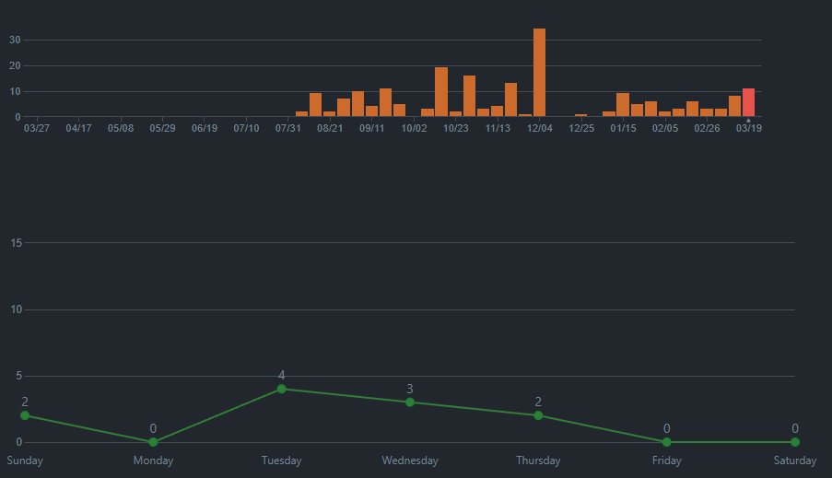

### Contributors

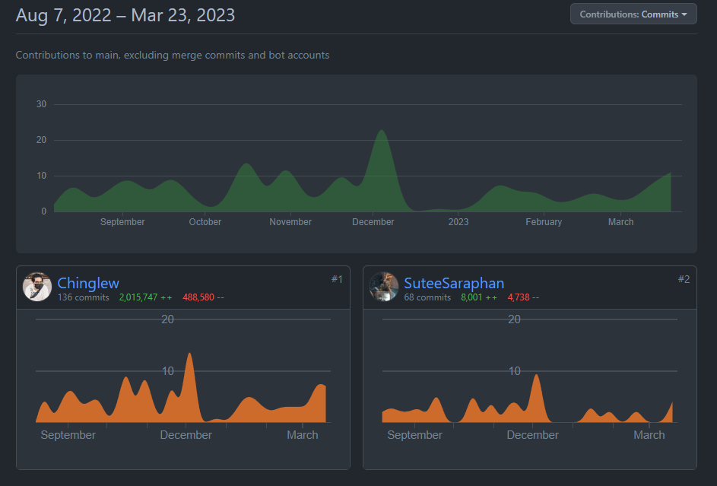

### Commit Messages

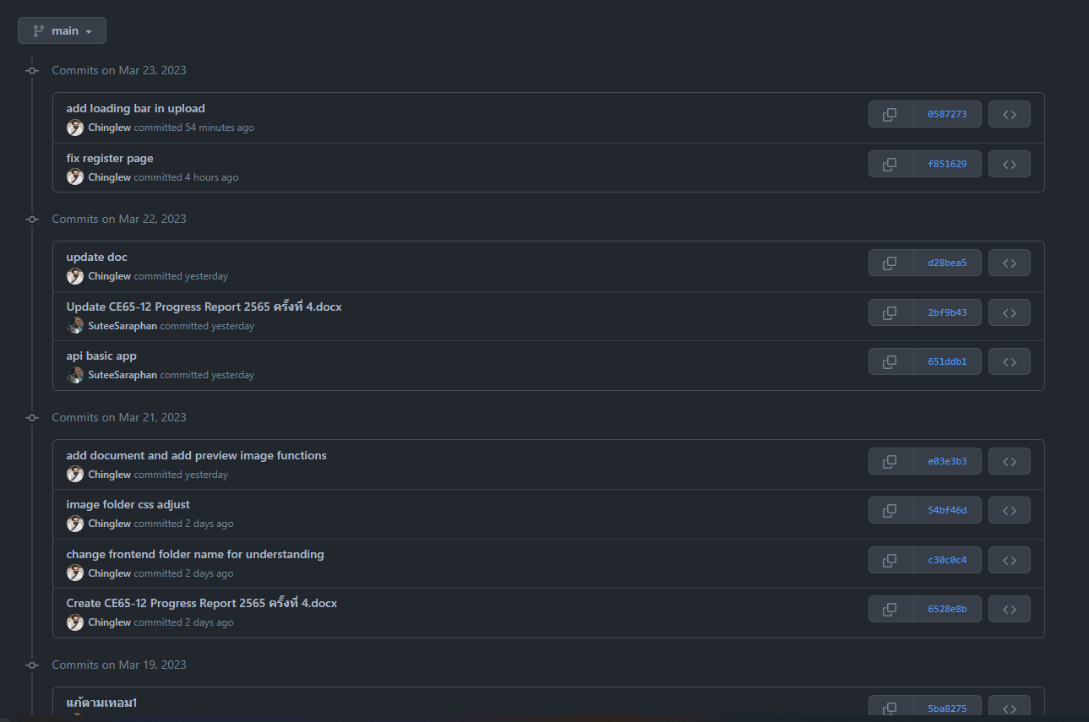

### Branch

